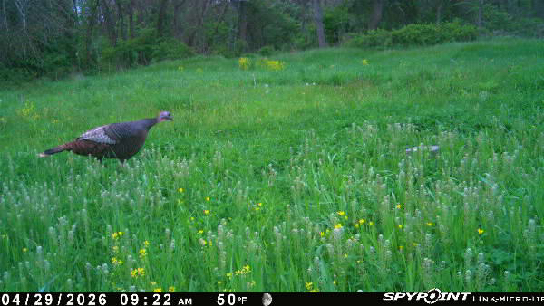
No Recreational Mow May
This winter’s deep freeze showed us something we don’t always want to admit: much of our landscape is bare when wildlife needs it most. Now a cool spring has finally pushed up lush green cover, and our first instinct is to mow it flat for the sake of appearance.
Recreational mowing is one of the most destructive forces you can unleash on grassland-dependent wildlife. A skunk might find one nest out of ten. A mower finds them all. Fawns, turkey nests, songbirds, and small mammals—anything tucked into that new growth—has a near-zero chance once the blades drop.
So this May through July, during the peak life cycle of the very creatures we enjoy seeing on our landscape, consider letting old fields and odd corners stand. Give the cover a chance to do what it was meant to do: provide life-sustaining shelter for the next generation of wildlife.
Your local chapter of Pheasants Forever is a group of like-minded individuals dedicated to protecting wildlife resources through public awareness, habitat education, and restoration. And it starts with something simple: not mowing up the next generation of wildlife.
To read the rest of the article, visit CVPF.net and click “Documents” for No Recreational Mow May. This hens' chicks will be out around the 25th of May mowing is more destructive
than predators and more than likely killing her if she is close to the day the chicks are hatching
The Deep Dive of Grasslands
Grasslands are far more than open spaces—they are the busiest nurseries on the landscape from May through July, holding layer upon layer of life that most people never see. Ground-nesting birds like meadowlarks, bobolinks, grasshopper sparrows, field sparrows, doves, killdeer, and upland sandpipers all rely on nothing more than a clump of grass to hide their eggs and raise their young, and a single mowing pass can erase an entire year of reproduction. Small mammals such as cottontails, voles, field mice, and shrews use the same cover for feeding, nesting, and escaping predators, forming the base of the food chain for hawks, owls, foxes, and coyotes. Pollinators—native bees, butterflies, moths, beetles—depend on undisturbed stems, soil, and early wildflowers to complete their life cycles, and when they disappear, so do the insects that feed songbirds, bats, and fish. Reptiles and amphibians move into grasslands for the warmth and safety of dense vegetation; turtles lay eggs in late May and June, and snakes, toads, and salamanders use the shaded base of grasses to hunt and regulate temperature. Even larger animals like deer rely on this habitat, with does hiding their fawns in grass barely knee-high, where stillness is their only defense—one a mower cannot overlook. A grassland in late spring is not “weeds,” but a living, breathing community performing the most important work it will do all year. When we mow during these months, we don’t just cut vegetation; we wipe out the next generation of wildlife. Letting fields and odd corners stand through the summer is one of the simplest, most impactful conservation choices any landowner can make.

